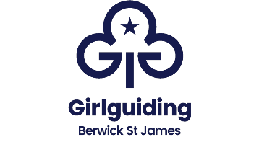
Games Equipment
These are kept in the store beside the Lodge.
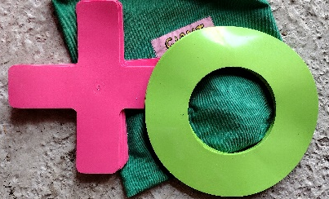
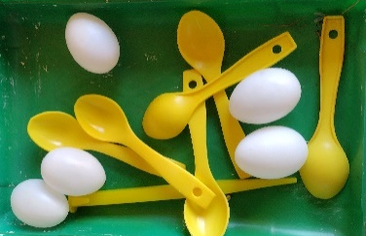
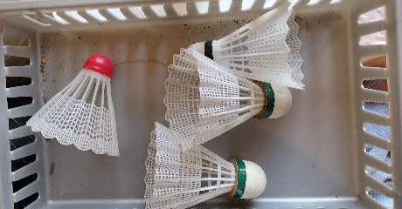
Girls must be supervised when games are being taken and returned to the store.

Egg & Spoons
Tick Tack Toe
Shuttle Cocks
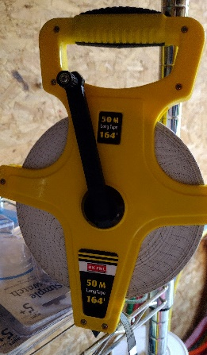
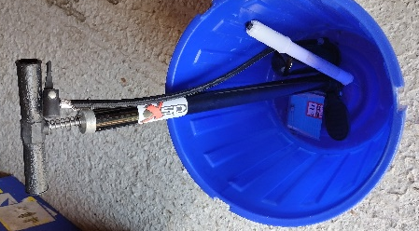
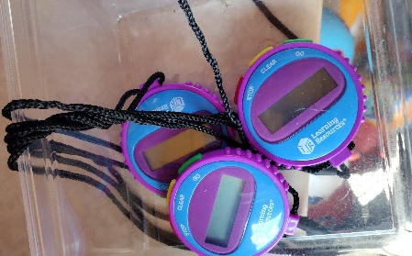
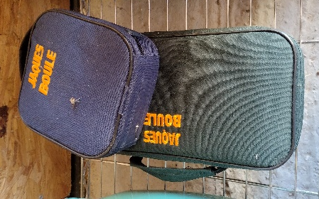
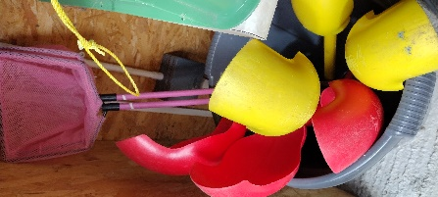
Fishing nets

Ball Pumps
50m tape
Timers
Boule sets
Ball scoops

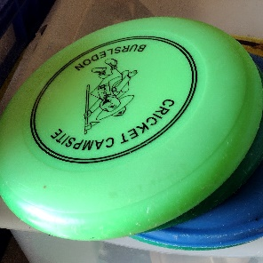
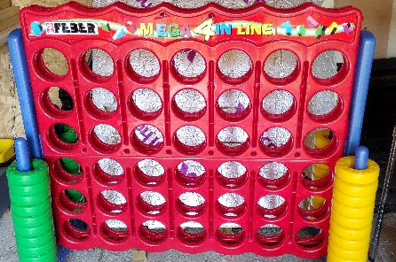
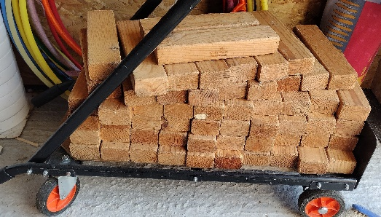

Frisbees
Giant 4 in a row
Giant Jenga
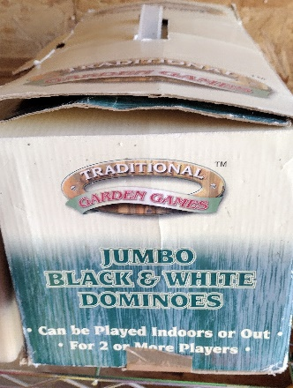
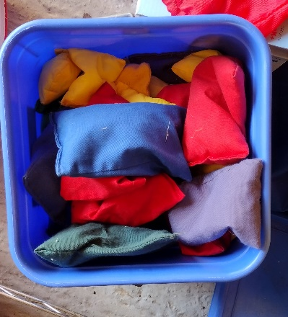
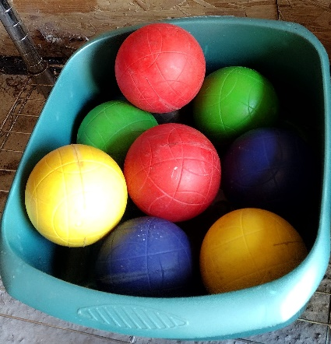
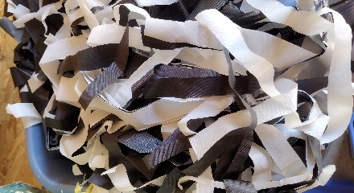
Bean Bags

Hard, heavy balls
Cheerleader pompoms

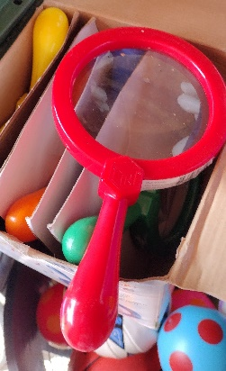
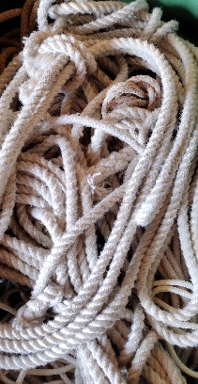
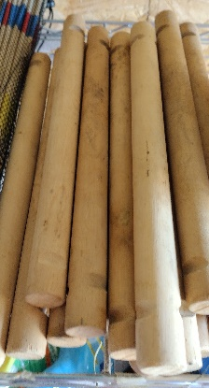
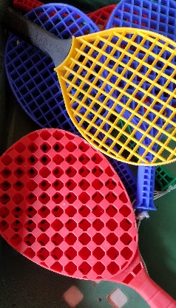
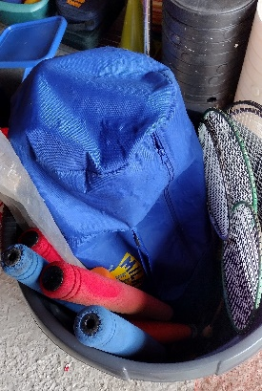
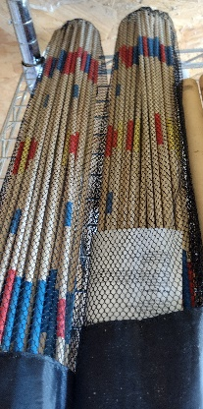

Kwik Cricket, Rounders bats

Magnifying Glasses

Rungs for ladders

Giant pick up sticks

Ropes

Rackets

Games Equipment
These are kept in the store beside the Lodge
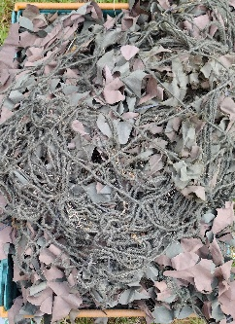
Girls must be supervised when games are being taken and returned to the store.
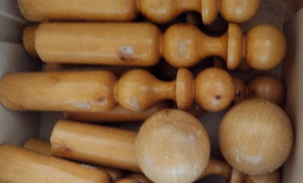
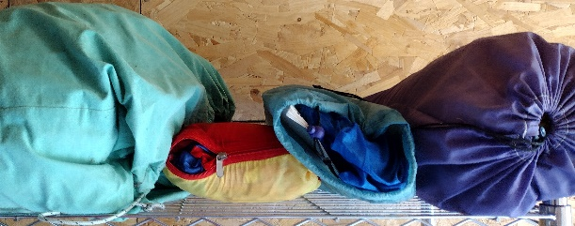

Camouflage nets

Wooden Skittles

Parachutes

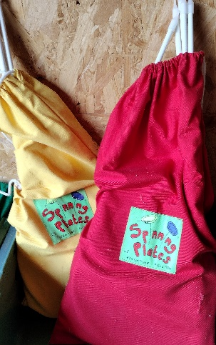
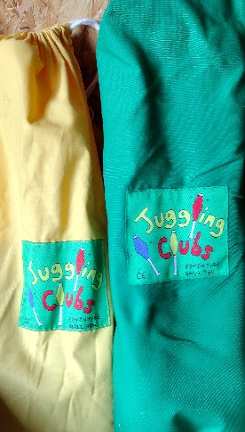
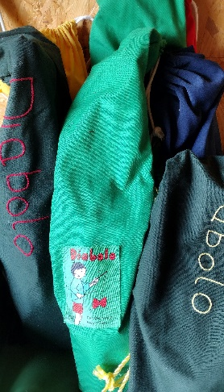
Quoits

Skipping Ropes

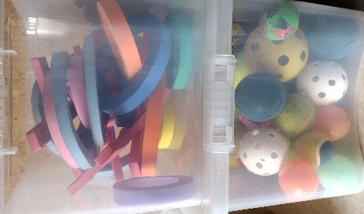
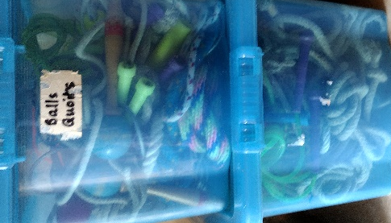

Spinning Plates x 2

Diabolo Sets x 3

Juggling Clubs x 2

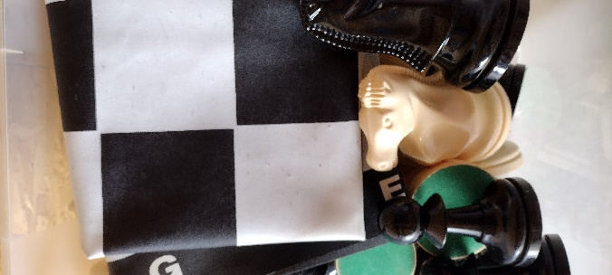
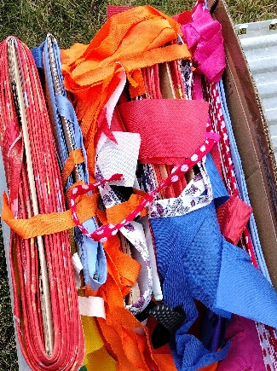
Airflow Balls

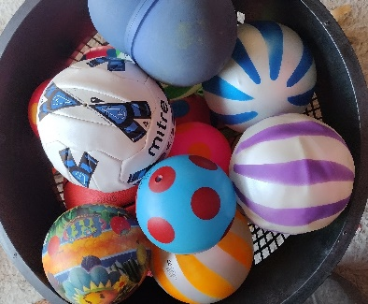
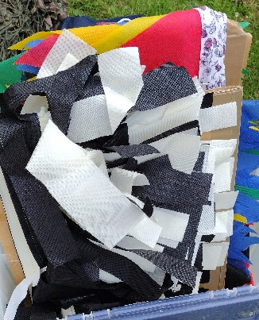

Tub of mixed balls

Bunting box 2

Bunting box 1

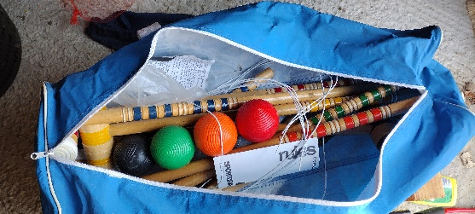
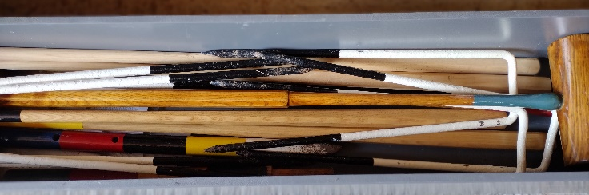

Croquet set in box (this is heavy)

Croquet Set in bag

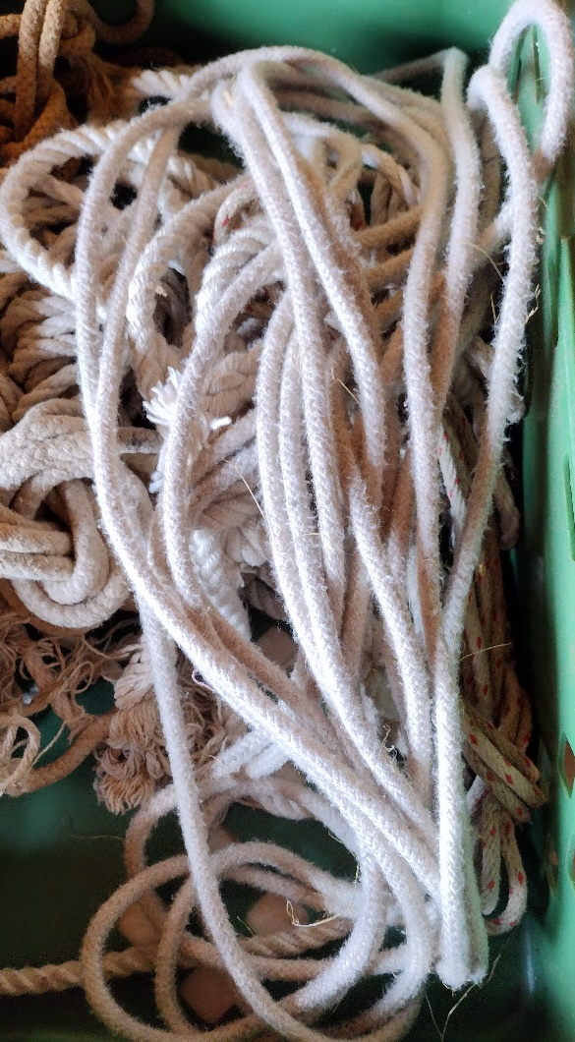

Games Equipment List

General Items Circus Items
1 x set of wooden Jenga on a trolley 2 x sets of 4 spinning plates in bags
1 x set of white draughts 2 x sets of 3 juggling clubs in bags
1 x set of black draughts 4 x diabolo in bags
1 Mega four in a line
1 x set of garden dominoes
1 x set of 4 steel boules
1 x set of 8 steel boules Sports Day Items
Cheerleader pompoms 9 x set of egg and spoons
4 x parachutes 1 x box coloured bean bags
6 x ball scoops 50m tape
1 x croquet set in wooden box hoops
1 x croquet set in a bag quoits
Kwik Cricket set in bag marker spots
Wooden skittles timers
Large tub of mixed balls airflow balls
Frisbees
2 x boxes of ropes
2 x boxes of large bunting
Inflater pump for balls
2 x sets of giant pick up sticks
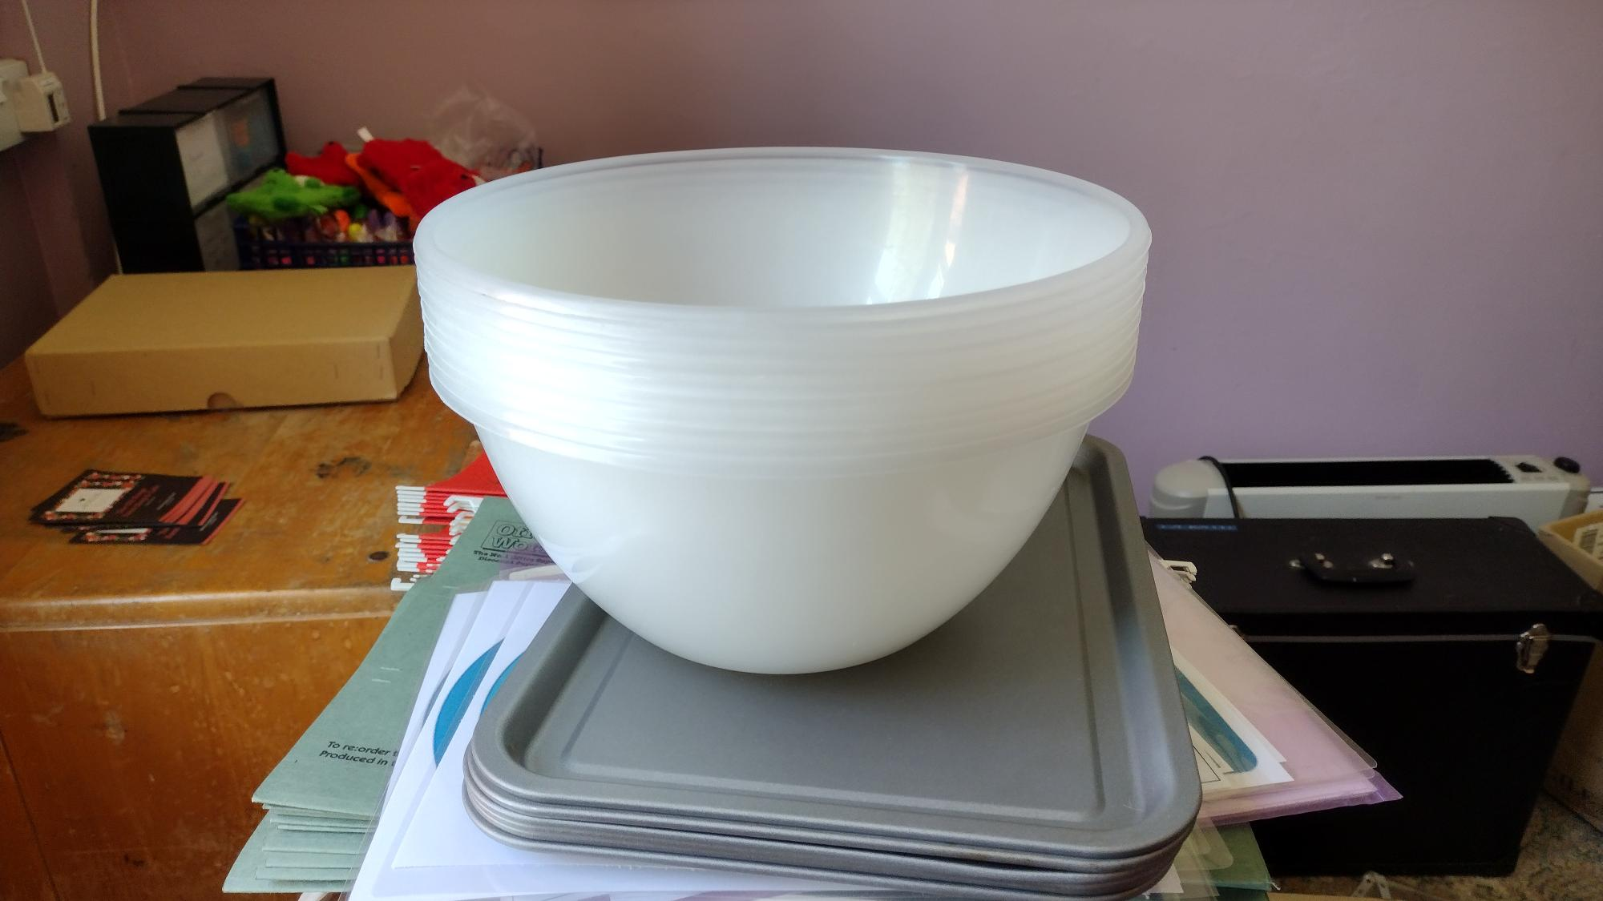
2 x camouflage nets
1 x box of large magnifying glasses
Rungs for making rope ladders
4 x parachutes various sizes

Flag Poles at the Front of the Site
Please only use these if you know how to hoist and lower a flag correctly. If girls are using them, please supervise. If the flag is hoisted incorrectly and gets stuck at the top of the pole, we have to pay for a cherry picker to get it down!

Items which can be hired: All at £5.00
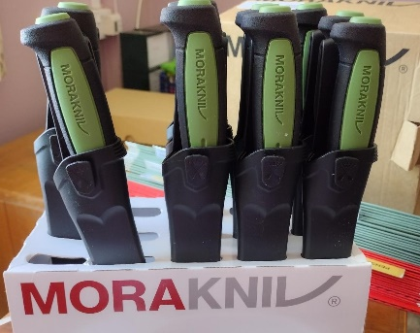
Camp / craft knives – set of 9

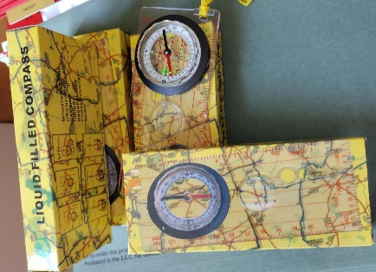
Set of 5 Silva Compass – set of 5

Set of cooking items for indoor use only
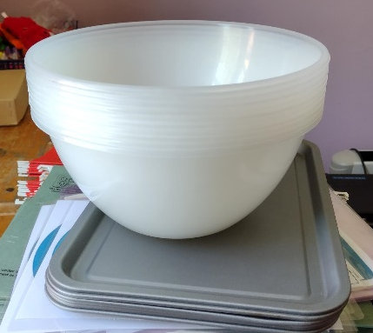
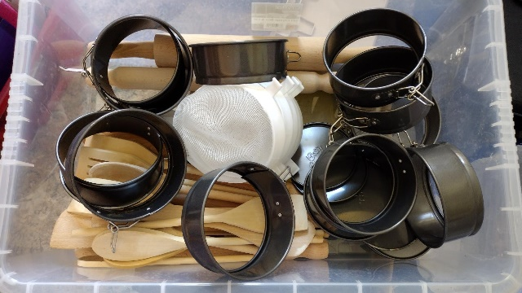

Quizzes
New quizzes for the village and site will be available soon.

