
The following awards are available through application to the Girlguiding Wiltshire South Awards Committee:
Wiltshire South Blue Butterfly Brooch  The Blue Butterfly can be awarded to recognize and acknowledge the valued service that any adult over the age of 18 has made to promote or advance Girlguiding in Wiltshire South. | 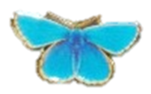
Wiltshire South The Young Inspirers Award  The Young Inspirers Award can be awarded to recognise and acknowledge the valued contribution that any young member volunteer, aged between 18-30 years who has made, and is continuing to promote Girlguiding in Wiltshire South either locally or across the county. | 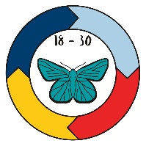
The Girlguiding Good Service Award  This is a national award but received at County level. This brooch may be given to an adult member of Girlguiding or a branch association for excellent service to guiding. To be eligible for a Good Service brooch the nominee must:  • Be a current member; and  • Have completed a role no more than six months before the application is made | 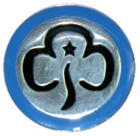

The Girlguiding Thanks badge

Any member of Girlguiding may present a Thanks badge after discussion
with a leader or commissioner:

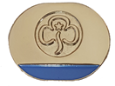
The Thanks badge can be either a brooch or lapel pin given to members and non-members of Girlguiding as a sign of appreciation for their support. The Thanks badge may only be given to a member of the Trefoil Guild if they have given service specifically to Girlguiding.

